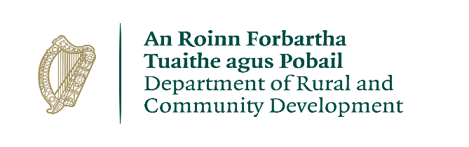

CLÁR 2018 Scheme Outline
First Response Support Measure (€1M)

Background
CLÁR (Ceantair Laga Árd-Riachtanais) is a targeted investment programme for rural areas that aims to provide funding for small infrastructural projects in areas that experience disadvantage. The aim of CLÁR is to support the sustainable development of identified CLÁR areas with the aim of attracting people to live and work there. The funding works in conjunction with local/Agency and other Departmental funding programmes and on the basis of locally identified priorities.

Funding Allocation for 2018
There is an allocation of €1M under the CLÁR programme for the First Response Support Measure. This measure will be operated directly by the Department of Rural and Community Development and is open to established organisations/groups that operate entirely on a voluntary basis, and are involved in emergency rescue/first response efforts.

It is important that applicant groups/organisations are formally established e.g. registered charity or not for profit etc. and are recognised, by public service bodies such as An Garda Síochána and the HSE, as an acceptable supplementary support body in relation to such activities.

Given the nature of the possible activities involved in relation to this measure and the need to ensure that support is made available to organisations/groups that are acceptable as part of the wider emergency response systems; applications will only be considered from organisations that can fully demonstrate this. In that regard it will be necessary to provide information/certification regarding the formal establishment of the group/organisation and also that demonstrates the status of the group/organisation from either An Garda Síochána or the HSE, in support of the application.

In addition, where applicant groups are members of a National/Regional organisation, all applications must be submitted centrally by the National/Regional organisation with an indication of prioritisation in the context of limited funding. In this context the funding to such applications may be limited to €200K per organisation.

Please note, that where groups have received funding in the past, particularly under CLÁR 2017, the Department may take that into account when making final decisions regarding project selection and may prioritise those that have not received funding previously.

Timelines

Scheme launch | 15th March
Applications to be received by the Department | By April 30th
Assessment and decisions, contracts | By May 31st
Project Completion/Drawdown | Sept/Oct

Detailed Measure Outline

Measure 4: First Response Support Measure
Recognising the critical role that first responders play in communities, and the level of interest in this particular funding stream in 2017, CLÁR 2018 will again consider support for established organisations that operate entirely on a voluntary basis and are currently involved in emergency rescue/first response efforts, to allow for the replacement of old and/or upgrade of existing vehicles/equipment directly involved in emergency rescue/first response efforts.

It will be necessary for applicants to demonstrate that the majority of their activities relate to emergency/first response/rescue situations as distinct from more routine, non-emergency, situations.

In the normal course CLÁR eligibility is based on projects being physically located within a designated CLÁR DED. Given the nature of the activities envisaged as well as the need to travel considerable distances, in some cases, to assist in rescue efforts and the need to maintain vehicles/equipment in practical/convenient locations; eligibility in this instance will be based on the ‘catchment area’ being served by the equipment and by demonstrating that the majority (at least 80%) of the need can be attributed to CLÁR DED’s.

Eligible Costs
Applications should detail all of the costs associated with the proposed project and only items of a capital nature that are integral to the project should be included. For example costs for items of equipment such as defibrillators and vehicles are eligible but other consumable items or training courses etc would not be eligible.

Rate of Aid
The scheme will provide up to 85% of the total cost of the equipment being applied for with minimum grant amount of €2,000 (requires project cost to be at least €2,353 to qualify for a grant of €2,000) or a maximum of €50,000. As detailed previously, a maximum grant of €200K may apply where Regional/National organisations are submitting applications on behalf of several member groups.

It is important in that instance, that Regional/National organisations submit all applications and don’t limit themselves, as there can be no guarantee that the Department will approve all/any applications submitted.

A match funding contribution of 15% is required.

Grant Payment arrangements
Grant payment arrangements will be in arrears and the detailed arrangements will be agreed with the successful grant recipients directly.

Application Process
Applications should include a detailed breakdown of estimated costs and all supporting documentation as requested in the application form. As outlined above Successful applicants will be required to comply with relevant public procurement guidelines.

Documentation should provide a clear evidence base for the assistance being requested and should be submitted directly to the Department at clar@drcd.gov.ie, by the 28th of April and on the attached application form. Any queries in relation to this scheme should be submitted to the Department via clar@drcd.gov.ie also.

Note: Where applicants are members of a Regional/National organisation all applications must be submitted by the Regional/National organisation and should not be submitted individually.

